IMPACT OF INFLATION

Virgil Kalluvely
University of Europe for applied Sciences,
Potsdam, Germany.
virgilkalluvely@gmail.com
Tekulapally Vamshi Abhishake
University of Europe for applied Sciences,
Potsdam, Germany.
vamshiabhishake@gmail.com

Shaik Mohammed Feroz
University of Europe for applied Sciences,
Potsdam, Germany.
feroz13143@gmail.com
Rajeev
University of Europe for applied Sciences,
Potsdam, Germany.
rajeev19981228@gmail.com
Deepu kushwaha
University of Europe for applied Sciences,
Potsdam, Germany.
deepupanipat236@gmail.com

Abstract— The paper tries to analyze the relationship of the inflation rate and exchange rate between India and the United States of America, ranging from 1980 to 2024. Based on publicly available data in this study, it examines the trends of inflation and exchange rates with the help of visualizations and computes the correlations between the variables. The report uses the theory of Purchasing Power Parity to compare actual exchange rates with those expected based on inflation differentials. Indeed, the findings indicate that while inflation rates drive exchange rates, deviations from PPP suggest the impact of other macroeconomic factors. This thus provides insight for policymakers and economists who monitor currency dynamics between the two countries.

Keywords—component, formatting, style, styling, data analytics, data visualization

Introduction

The relationship between the inflation rate and the exchange rate is one of the most important areas of study in the field of economics. In as much as exchange rate movements reflect changes in the relative values of currencies between countries, inflation rates measure the rate at which the general price level of goods and services rises. After that, the research will be oriented to the analysis and comparison of inflation rates and exchange rates between two large economies, namely India and the United States of America, for the period 1980-2024. For policymakers, investors, and economists, understanding the dynamics of these particular indicators forms the basis for the forecasting of economic trends and monetary management policies in general, as well as assessing the level of international competitiveness.

Ease of Use

This analysis, using the Python libraries pandas and plotly, will give an extensive overview of these economic indicators and how they relate to one another. We then visualized the trends across three important indicators with the help of the plotly library. To quantify these relationships, we computed a correlation matrix which gave us strong positive relationship between exchange rate and India's inflation. Very low or weak positive relation of the United States' inflation and exchange rate. This analysis epitomizes the complex dynamics of exchange rates and inflation.

OBJECTIVE

The report, therefore, undertakes a detailed analysis of the exchange rate, INR/USD, and the inflation rates for both India and the United States. The following are the objectives that are being aimed at:
- Determine the relation between inflation rates and the exchange rate, incorporating lag effects.

- Verify the Purchasing Power Parity theory by comparing the actual exchange rate to what is expected if the theory were to hold from the differentials in inflation rates.

- Check if the deviations in the expected PPP-based exchange rate hold for other economic causes that may contribute to changes in the rate of exchange.

Abbreviations and Acronyms

1. PPP– Purchasing Power Parity
2. GDP – Gross Domestic Product
3. API – Application Programming Interface
4. PCA – Principal Component Analysis
5. CPI – Consumer Price Index
6. MPC – Monetary Policy Committee
7. ECR – Exchange Rate Conversion
8. BOP – Balance of Payments
9. FPI – Foreign Portfolio Investment
10. IMF – International Monetary Fund
11. OECD – Organization for Economic Co-operation and Development
12 EIA - Energy Information Administration
13. VIX – Volatility Index
14. RBI – Reserve Bank of India
Abbreviations and acronyms as mentioned above are applicable in the context of the report, especially those sections dealing with economic indicators, techniques of data analysis, and international financial institutions.

Units

1. Year (Year)
- Unit: Year
- For the period for the analysis, starting from 1980 up to 2024.

2. Exchange Rate (INR/USD)
- Unit: Indian Rupee per US Dollar (INR/USD)
- Value of one US Dollar in Indian Rupees.

3. Inflation Rate
- Unit: Percentage (%)
- Used to represent the rate at which the general level of prices for goods and services rises, leading to a decrease in purchasing power. This applies to both India and the United States.

4. Cumulative Product
- Unit: Ratio (dimensionless)
- Applied in computing the expected exchange rate from the Purchasing Power Parity theory. It represents the compounded effect of the inflationary rates over time.

5. Correlation Coefficient
- Unit: Dimensionless-ranging from -1 to 1
- Measures the strength and direction of a linear relationship between two variables-for example, inflation rates and exchange rates.

These measures are basic to an understanding and interpretation of the economic data, trends, and analysis presented throughout this report.

Equations

- Purchasing Power Parity Formula –

The Purchasing Power Parity theory states that the exchange rate between two nations should change in response to the difference in inflation rates between the two nations. The formula to compute the expected exchange rate from PPP is given as:
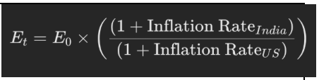

Where:

Et = Expected exchange rate at time t

E0 = Initial exchange rate (at the starting year)

Inflation RateIndia= Inflation rate in India for a given year

Inflation RateUS= Inflation rate in the United States for the same year

This equation would calculate the expected exchange rate based on accumulated differential impact of the inflation rates between India and the US.

Correlation Coefficient Formula-

The formula for computing the expected exchange rate at each successive year is:

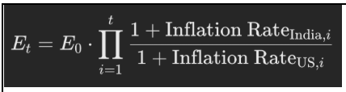

Where:

Et​: Expected exchange rate at time ttt.

E0​: Initial exchange rate (exchange rate in the first year of the dataset).

Inflation RateIndia,i​: Inflation rate in India at year i

Inflation RateUS,i​: Inflation rate in the United States at year i

∏i=1t​: Cumulative product from year 1 to year t, applying the inflation differentials.

- Correlation Coefficient Formula-

The correlation coefficient is a measure of the intensity and direction of a linear relationship between two variables-for instances, an exchange rate and\inflation. The formula for the correlation coefficient is given by

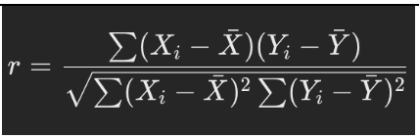

Where

Xi​ and Yi​ = Data points of the two variables being compared (e.g., Exchange Rate and Inflation Rate)

Xˉ and Yˉ = Mean values of X and Y

r= Correlation coefficient between the two variables
The correlation coefficient (r) ranges from -1 to +1:

r = 1: Perfect positive correlation

r = −1: Perfect negative correlation

Methodology

- Data Collection:

Inflation Data: - The inflation data of India and the United States was loaded from an inflation rate file across several years and multiple countries, 'Inflation_Rates_Transformed.csv'.

Exchange Rate Data: -The exchange rate data for the Indian Rupee against the US Dollar, ranging from 1980 to 2024, was loaded from the file 'USD_INR_Exchange_Rates_1980_2024.csv'.

- Data Preprocessing:

Filtering Inflation Data:- To filter the inflation data to include only India and the United States, select only the relevant rows in the dataset. Pivoting Inflation Data: With this simple pivot of the filtered inflation data into columns for the inflation rates of India and the United States indexed by year, one can easily compare the inflation rates amongst these two countries over time.

Merging Data: -The exchange rate information will be joined on the Year column of the inflation data so as to get into a single data frame all the relevant variables that are the exchange rate, the inflation rate for India, and the inflation rate for the United States.

- Visualization:

Visualize Trends:- Generate three subplots using plotly graph_objs and make_subplots that show the trend in the exchange rate, INR/USD, the inflation rate for India, and the inflation rate for the United States. Update each subplot with a title and proper axis labels.

Comparative Visualization:- The second plot comparing the exchange rate against the inflation rates of both countries was plotted to visualize the relationship that exists between the different variables.

Results

Few results from the research work questions are given or provided below so that we can imagine what and where this research leads us to, and which can help us to understand what the graphical image is representing.

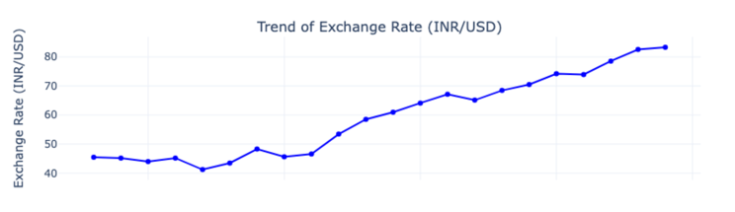
Fig.1. Trends of Exchange Rate (INR/USD)

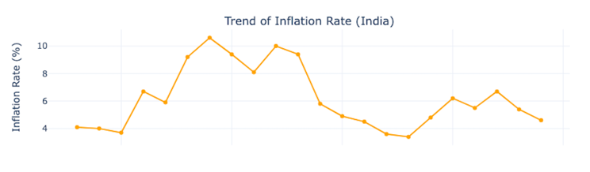

Fig.2. Trend of Inflation Rate for India

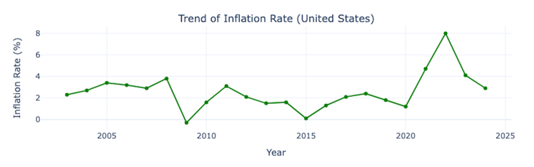

Fig.3. Trend of Inflation Rate for United States (US)

The pictures above help to visualize and really depict the fluctuations and trends in the exchange rates between the Indian Rupee, denoted by INR, and the US Dollar, represented by USD; it also illustrates the inflation rates for both India and the United States over different periods of time, so the economic conditions in these two countries can be compared. This all-inclusive representation provides an amazingly clear and intricate visualization of how inflation has developed and transformed over the years in both countries. Moreover, it also depicts how the exchange rates have witnessed fluctuations and adjustments due to and because of these prevalent inflationary trends.

Conclusion

The Research takes up a comprehensive and detailed examination, besides an extensive analysis, of the multi-dimensional and complex relationship that exists between the rates of inflation and the rates of exchange, with a special focus on the nations of India and the United States. This is accomplished through the judicious use of a wide array of analytical tools and methodologies presently in practice. These tools and methodologies are put into researching numerous diverse trends, making in-depth analyses of various correlations, and applying theoretical models relevant to extracting deeper insights.

Such insight contributes to a much more profound comprehension of this major economic interplay. This would, overall, be a proper basis of research on the relationship between inflation and exchange rates in the long term with an emphasis on the PPP theory and what factors might tend to cause deviation.

Future Analysis:

Lag Effects: - Inflation may be influencing the exchange rate with a little lag in time. For this, one can use lag variables of inflation and then re-compute the correlation to incorporate time delays.

Statistical Modelling: - It is possible to estimate advanced econometrical models, such as VAR or Cointegration models, to analyse the time-varying dynamic relationships of inflation and exchange rates.

Other Economic Factors: - You can further add other economic variables like interest rates, trade balance, or capital flows to the analysis to see how they interact with inflation in determining nominal exchange rates

Acknowledgment

We would like to thank our prof. Dr Talha Ali Khan for his encouragement to make this proposal. We are immensely grateful for his insights and expertise in Data Analysis which paved the way for us to explore this new point of view.

References

[1] A. O. Krueger, "Some economic costs of exchange control: The Turkish case," * The Purchasing-Power-Parity Theory of Exchange Rates: A Review Article *, vol. 23, no. 1, pp. 1–20, 1976.

[2] E. R. Tufte, *The Visual Display of Quantitative Information*, 2nd ed., Cheshire, CT: Graphics Press, 2001

